caXchange – ScenPro, Inc.
Ekagra

Cancer Center Hub Client (CCHC) v1.5
Test Plan

Document Change History
Version Number | Date | Contributor | Description
1.0 | October 2008 | Jennifer Brush | Initial Draft


Updated October 22, 2008

Table of Contents

1 Introduction 4
1.1 Scope 5
1.1.1 In Scope 5
1.1.2 Out of Scope 5
1.2 Quality Objective 5
1.2.1 Primary Objective 5
1.2.2 Secondary Objective 5
1.3 Roles and Responsibilities 6
1.3.1 Developer 6
1.3.2 QA 6
1.4 Assumptions for Test Execution 6
1.5 Constraints for Test Execution 7
1.6 Definitions 7
2 Test Methodology 9
2.1 Purpose 9
2.1.1 Overview 9
2.1.2 Usability Testing 9
2.1.3 Unit Testing (Multiple) 9
2.1.4 Iteration/Regression Testing 9
2.1.5 Final release Testing 9
2.1.6 User Acceptance Testing 10
2.1.7 Testing completeness Criteria 10
2.2 Test Levels 10
2.2.1 Build Tests 10
2.2.2 Milestone Tests 10
2.2.3 Release Tests 11
2.3 Bug Regression 11
2.4 Bug Triage 11
2.5 Suspension Criteria and Resumption Requirements 11
2.6 Test Completeness 11
2.6.1 Standard Conditions: 11
2.6.2 Bug Reporting & Triage Conditions: 12
3 Test Deliverables 13
3.1 Test Approach 13
3.1.1 Clinical Trials Object Data System (CTODS) Data Service Group 13
3.1.2 Clinical Trials Object Data System (CTODS) Lab Viewer Group 14
3.2 Test Cases 14
3.2.1 Test Cases 14
3.2.2 Test Case Description 16
3.2.3 Requirements Traceability Matrix 21
3.3 Defect Tracking & Debugging 22
3.3.1 Testing Workflow 22
3.3.2 Defect reporting using GFORGE 22
3.4 Reports 24
3.4.1 Testing status reports 24
3.4.2 Test Final Report - Sign-Off 24
3.5 Responsibility Matrix 24
4 Resource & Environment Needs 25
4.1 Testing Tools 25
4.1.1 Tracking Tools 25
4.2 Test Environment 25
4.2.1 Hardware 25
4.2.2 Software 25
4.3 Bug Severity and Priority Definition 26
4.3.1 Severity List 26
4.3.2 Priority List 26
4.4 Bug Reporting 27
5 Terms/Acronyms 28

Introduction
The caXchange project consists of the caXchange ESB, CTODS Lab Viewer, the Cancer Center Hub Client (CCHC) and their grid services. This document details the test plan for the Cancer Center Hub Client.

Cancer Center Hub Client
The Cancer Center Hub Client is a software application residing external to the caXchange hub. This service is able to receive HL7v3 CT Laboratory Observation Periodic Report messages and persist the domain related data contained in the message into an instance of the CTODS Lab Viewer database. This software component will reside on a local user machine, external to the caXchange ESB.
The CCHC grid services (which persists the laboratory data into the CTODS Lab Viewer Database) is just one of many destinations (Endpoints) that the HL7v3 Laboratory Observation Periodic Report message can be routed to. It is expected that data will be routed to additional Endpoints as they are identified in future releases.
The CCHC is a light client application developed to facilitate the transformation of .CSV and HL7v2 to HL7v3 format. Building this application adds a significant capability to caXchange by allowing custom message types to be transformed and routed through the caXchange ESB. In the original caXchange v 0.5, laboratory data from a cancer center was being transformed, routed, and persisted into the CTODS database, but there was no visual and user friendly GUI tool to set up the administration of these transformed messages. Based on the use cases identified by the SMEs of the Interoperability project, a new requirement was identified that made the transformation of lab data a critical piece of the interoperability project.

Scope

In Scope
The caBIG Workspace – caXchange Test Plan defines the unit, integration, system, regression, and Client Acceptance testing approach. The test scope includes the following:
- Testing of all functional, security and use cases requirements listed in the Use Case document.
- Quality requirements and fit metrics of Cancer Center Hub Client
- End-to-end testing and testing of interfaces of all systems that interact with the Cancer Center Hub Client

Out of Scope
The following are considered out of scope for CCHC Test Plan and testing scope:
- Functional requirements testing for systems outside CCHC
- Testing of Business SOPs, disaster recovery and Business Continuity Plan.
- Performance test are out of scope due to time and resource constraints
- Usability Testing is out of scope due to time and resource constraints

Quality Objective

Primary Objective
A primary objective of testing application systems is to: assure that the system meets the full requirements, including quality requirements (AKA: Non-functional requirements) and fit metrics for each quality requirement and satisfies the use case scenarios and maintain the quality of the product. At the end of the project development cycle, the user should find that the project has met or exceeded all of their expectations as detailed in the requirements.

Any changes, additions, or deletions to the requirements document, Functional Specification, or Design Specification will be documented and tested at the highest level of quality allowed within the remaining time of the project and within the ability of the test team.

Secondary Objective
The secondary objective of testing application systems will be to: identify and expose all issues and associated risks, communicate all known issues to the project team, and ensure that all issues are addressed in an appropriate matter before release. As an objective, this requires careful and methodical testing of the application to first ensure all areas of the system are scrutinized and, consequently, all issues (bugs) found are dealt with appropriately.

Roles and Responsibilities

Developer
An organization selected and funded by NCICB to participate in a specific Workspace to undertake software or solution development activities. Responsible for:
(a) Developing the system/application
(b) Developing Use cases and requirements
(c) Conducting Unit, system, regression and integration testing
(d) Supporting user acceptance testing

QA
Following will be QA team roles and responsibilities. A resource selected and funded by NCICB to undertake formal testing, validation, and application of products or solutions developed by Workspace Developers. Responsible for:
(a) Contributing to Use case, requirement development through review
(b) Contributing to develop and execution of the development test scripts through review
(c) Conducting Full User Acceptance, regression, and end-to-end testing; this includes identifying testing scenarios, building the test scripts, executing scripts and reporting test results

Assumptions for Test Execution

The CCHC testing effort has inherent dependencies on the existing NCICB products involved in the architecture and other factors such as business, software, or personnel aspects. These dependencies are documented as assumptions in this section.
- For User Acceptance testing, the Developer team has completed unit, system and integration testing and met all Requirement’s (including quality requirements). Since there are no adopters for this phase of caXchange user acceptance testing will be informally conducted by developers.
- Test results will be reported on daily basis using GForge. Failed scripts and defect list from GForge with evidence will be sent to the Developer directly.
- Use cases have been developed for Acceptance testing. Use cases are approved by test lead.
- Test scripts are developed and approved.
- caAdapter – for successful conversion of CSV and HL7v2 data into valid HL7 v3 messages, and for a stable production release of version 1.3.
- GU source data – for containing complete, accurate data, and valid values with respect to HL7 v3 standards. As noted below, it is assumed that some values will be invalid and that this will allow the project to demonstrate how invalid data is handled.
- CLM – for auditing and logging of the actions in the caXchange.
- CSV – HL7 transformation service that was deployed in 0.5 version of caXchange and has been moved to the Cancer Center Hub Client (CCHC) v1.5 and the client will interact with other systems (such as caAdapter, C3PR) to formulate a complete HL7 V3 message.
- Some invalid data will be provided by GU. The data will be considered invalid if it does not match HL7 v3 standards for its intended data element. This invalid data is actually useful for the project to be able to demonstrate how invalid data is handled (e.g. audit logs, etc.).
- Only valid XML instances of the HL7 v3 CT Lab message will be persisted using the CTODS Data Service. This will ensure that the data that is loaded in the database is not incomplete.

Constraints for Test Execution

- Developer will receive a consolidated list of request for test environment set up, user accounts set up, data set (actual and mock data), defect list, etc. through GForge after the initial Adopter testing kick off meeting.
- Developer will support ongoing testing activities based on priorities

Definitions
Bugs: Any error or defect that cause the software/application or hardware to malfunction. That is also included in the requirements and does not meet the required workflow, process or function point.

Enhancement:
1) Any alteration or modification to the existing system for better workflow and process.
2) An error or defect that causes the software/application or hardware to malfunction.
Where 1) and 2) is NOT included in the requirements can be categorized as an enhancement.

Enhancement can be added as a new requirement after appropriate Change Management process.

Test Methodology

Purpose

Overview

The purpose of the Test Plan is to achieve the following:
- Define testing strategies for each area and sub-area to include all the functional and quality (non-functional) requirements.
- Divide Design Spec into testable areas and sub-areas. Be sure to also identify and include areas that are to be omitted (not tested) also.
- Define bug-tracking procedures.
- Identify testing risks.
- Identify required resources and related information.
- Provide testing Schedule.

Usability Testing
Usability testing focuses on measuring application’s capacity to meet its intended purpose. Usability testing measures the usability, or ease of use, of a specific use case or use cases. Usability testing Usability testing will not be conducted on the Cancer Center Hub Client (CCHC) v1.5 due to time constraints.

Unit Testing (Multiple)
Unit Testing is conducted by the Developer during code development process to ensure that proper functionality and code coverage have been achieved by each developer both during coding and in preparation for acceptance into iterations testing.

Iteration/Regression Testing
At each iteration, a debriefing should be held. Specifically, the report must show that to the best degree achievable during the iteration testing phase, all identified severity 1 and severity 2 bugs have been communicated and addressed. At a minimum, all priority 1 and priority 2 bugs should be resolved prior to entering the beta phase.

Important deliverables required for acceptance into Final Release testing include:
- Application set up
- Installation instructions
- All documentation (beta test scripts, manuals or training guides, etc.)

Final release Testing
Assuming critical bugs are resolved during previous iterations testing- Throughout the Final Release test cycle, bug fixes will be focused on minor and trivial bugs (severity 3 and 4). Testing will continue its process of verifying the stability of the application through regression testing (existing known bugs, as well as existing test cases).

The milestone target of this phase is to establish that the application under test has reached a level of stability, appropriate for its usage (number users, etc.), that it can be released to the end users and caBIG community.

User Acceptance Testing
User acceptance testing is typically performed by users of the system. A limited and informal user acceptance testing will be performed by members of the development team. In future releases, user acceptance testing will be performed by adopters of the Cancer Center Hub Client (CCHC).

Testing completeness Criteria
The milestone target is to place the release/app (build) into production after it has been shown that the app has reached a level of stability that meets or exceeds the client expectations as defined in the Requirements, Functional Spec., and caBIG Production Standards.

Test Levels
The test categories and test levels are defined below:

Build Tests

Level 1 - Build Acceptance Tests
System will be checked to see if the proper Development Release Document plus other build related information (drop point, etc.) is in place. The objective is to determine if further testing is possible. If any Level 1 test case fails, the build is returned to developers un-tested.

Level 2 - Smoke Tests
The objective is to determine if further testing is possible. These test cases will emphasize breadth more than depth. All components will be touched, and every major feature should be tested briefly by the Smoke Test. If any Level 2 test case fails, the build is returned to developers un-tested.

Level 2a - Bug Regression Testing
Every bug that was “Open” during the previous build, but marked as “Fixed,” needs re-testing. The current build under test will need to be regression tested as well. Finally, once the smoke test is completed, all resolved bugs will be retested.

Milestone Tests

Level 3 - Critical Path Tests
Critical Path test cases must pass by the end of every 2-3 Build Test Cycles. They will not need to be tested every drop, but must be tested at least once per milestone. Thus, the Critical Path test cases must all be executed at least once during the Iteration cycle, and once during the Final Release cycle.

Release Tests

Level 4 - Standard Tests
Test Cases that need to be run at least once during the entire test cycle for this release. These cases are run once, not repeated as are the test cases in previous levels. Functional Testing and Detailed Design Testing (Functional Spec and Design Spec Test Cases, respectively). These can be tested multiple times for each Milestone Test Cycle (Iteration, Final Release, etc.).
Standard test cases usually include Installation, Data, GUI, and other test areas.

Bug Regression
All bugs that are resolved as “Fixed, Needs Re-Testing” will be regressed when Testing team is notified of the new drop containing the fixes. When a bug passes regression it will be considered “Closed, Fixed”. If a bug fails regression, the testing team will notify development team by entering notes into GForge. When a high severity bug fails regression, the Testing team should also put out an immediate email to development. The Test Lead will be responsible for tracking and reporting to development and product management the status of regression testing.

Bug Triage

The Test Lead, Product Manager, and Development Lead should all be involved in these triage meetings. The Test Lead will provide required documentation and reports on bugs for all attendees. The purpose of the triage is to determine the type of resolution for each bug and to prioritize and determine a schedule for all “To Be Fixed Bugs’. Development will then assign the bugs to the appropriate person for fixing and report the resolution of each bug back into the GForge bug tracker system. The Test Lead will be responsible for tracking and reporting on the status of all bug resolutions.

Suspension Criteria and Resumption Requirements
A bug report should be filed by the development team. After fixing the bug, the development team will follow the drop criteria (described above) to provide its latest drop for additional testing. At that time, the testing team will regress the bug, and if passes, continue testing the module.

Test Completeness
Testing will be considered complete when the following conditions have been met:

Standard Conditions:
- When testing team and Developers, agree that testing is complete, the app is stable, and agree that the application meets functional requirements.
- Script execution of all test cases in all areas have passed.
- Automated test cases have in all areas have passed.
- All high priority bugs have been resolved and closed.
- NCI approves the test completion
- Each test area has been signed off as completed by the Test Lead.
- 50% of all resolved priority 5 bugs have been successfully re-regressed as final validation.

Bug Reporting & Triage Conditions:
- Bug find rate indicates a decreasing trend prior to Zero Bug Rate (no new Severity. 1/2/3 bugs found).
- Bug find rate remains at 0 new bugs found (Severity 1/2/3) despite a constant test effort across 3 or more days.
- Bug severity distribution has changed to a steady decrease in Severity. 1 and 2 bugs discovered.
- No ‘Must Fix’ bugs remaining prior despite sustained testing.

Test Deliverables
Testing will provide specific deliverables during the project. These deliverables fall into three basic categories: Documents, Test Cases / Bug Write-ups, and Reports. Here is a diagram indicating the dependencies of the various deliverables:

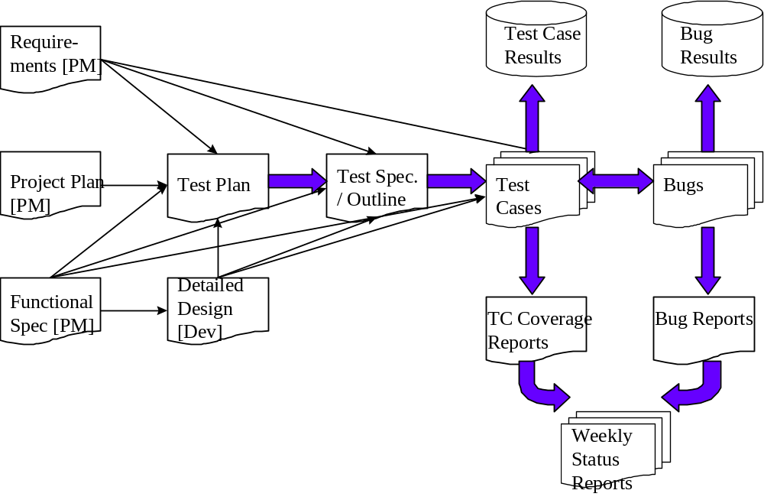

As the diagram above shows, there is a progression from one deliverable to the next. Each deliverable has its own dependencies, without which it is not possible to fully complete the deliverable.

The following page contains a matrix depicting all of the deliverables that Testing will use.

Test Approach

Clinical Trials Object Data System (CTODS) Data Service Group

Message Persistence
Testing and verification of the persistence of the HL7 CT Lab messages in the CTODS data repository will be accomplished by functional tests and query and statistical analysis. Initial tests will target valid and invalid user ids, passwords and CT Lab messages as input to the CTODS service. Additionally, counts of various data features (total volume of records, counts of distinct clinical trials, patients, etc.) can be executed on the initial GU data set, the C3PR-added data, and the tables in CTODS and then compared to see if they reconcile. Spot check queries shall also be performed on CTODS to verify that a targeted subset of initial records was successfully loaded into CTODS.

Cancer Center Hub Client (CCHC) Group

User Credential
Researchers and other users should be allowed to login with the valid user name and passwords. Users must be provided with a GUI application to transform lab messages and populate them in the CTODS Lab Database.

Transformation - Origin
Users must be able to set the location of the directory where messages to be transformed will be located. This directory may be on the local machine or available via a URL on an external server.

Transformation - Destination
Users must be able to set the location of the directory where transformed messages will be sent, ready for routing to caXchange ESB and subsequently the CTODS Lab Database. The directory may be on a local machine or available via URL on an external Server.

Message Format
User must be able to select the format of the message to be transformed. Users must be able to select from HL7v2, CSV, or HL7v3 (no transformation).

Test Cases

Test Cases
Here are some of the test cases that will be tested for the CCHC group. The test cases are sequential in the order of dependency.

Test Case No | Requirement Id | Features to be tested | Test Cases
1 | 6.1 | Users must be able to login securely with valid user name and password in GUI application. | Secure Login - valid user name and password
2 | 6.1 | Users must be able to login securely with valid user name and password in GUI application. | Secure Login – invalid user name password
3 | 6.1 | Users must be able to login securely with valid user name and password in GUI application. | Secure Login- valid user name and invalid password
4 | 6.1 | Users must be able to login securely with valid user name and password in GUI application. | Secure Login – invalid user name and valid password
5 | 6.1 | Users must be able to login securely with valid user name and password in GUI application. | Secure Login – no user name and password
6 | 3.1 | Persist HL7v3 Message | CTODS data service persist message – Route Valid CT Lab Messages to CTODS Service
7 | 3.3,3.4 | Record Counts | CTODS data service persist message – Record counts
8 | 3.3,3.4 | Query Data | CTODS data service query data-Query data via Lab Domain Model API
9 | 6.2 | Create a new study in CTODS Lab Database | Study Creation – study creation with corresponding study id
10 | 6.2 | Create a new study in CTODS Lab Database and check when it rollback | Study Creation – study creation with rollback
11 | 6.2 | Check the Resource Property file for the corresponding study creation | Study Creation – study creation get corresponding study id in database
12 | 6.2 | Check the multiple Resource Property file for the corresponding study creation | Study Creation - study creation with multiple Resource Property
13 | 6.2 | Query Resource Property file for the study creation | Study Creation – study creation Query Resource Properties
14 | 6.2 | Get the corresponding meta data for the created study creation | Study Creation - study creation get Service Security Meta data
16 | 6.2 | Registration subject with non approved study | Registration Consumer – register patient with rollback and doesn't create patient id
17 | 6.2 | Register new subject with success | Registration Consumer – register patient with commit register
18 | 6.2 | Rollback on register new subject | Registration Consumer – register patient with rollback on register
19 | 6.2 | Check the resource property file of the new registration | Registration Consumer – get resource property of registration consumer
20 | 6.2 | Check the multiple resource property file of the new registration | Registration Consumer – get multiple resource property of registration consumer
21 | 6.2 | Query the resource property of the new registration | Registration Consumer – Query resource property of registration consumer
22 | 6.2 | Check the meta data file for the corresponding registration subject | Registration Consumer – get service security meta data registration consumer
25 | 6.3 | Check if particular search result can be loader to external system | Load Lab Activities- lab load on search record
27 | 6.3 | Seamless login in CCHC with required credentials using WebSSO | Login to CTODS Lab Viewer using encryption and ensure that it is authenticated with WebSSO
28` | 6.3 | View the security marks in the home page such as 128 bit SSL encryption key and secure https port | To ensure that security is incorporated in CTODS Lab Viewer Applicaiton
29 | 6.3 | Verify the range of data load | Load Lab Activities- data will be committed to C3D Lab Loader Area. Data within the data range will load and outside will not load

Test Case Description

Test case 1: Secure Login -Valid user name and password
This test case uses a valid user with a valid password. The aim of the test case is to verify that a user with valid credentials can be authenticated by CCHC. The tester issues the request and verifies that CCHC replies that the user is authenticated or prompts for any deficiency.

Test case 2: Secure Login – Invalid user name and password
This test case uses an invalid user with an invalid password. The aim of the test case is to verify that a user with valid credentials can be authenticated by the CTODS Lab Viewer. The tester issues the request and verifies that the CTODS lab viewer replies that the user is authenticated or prompts for any deficiency.

Test case 3: Secure Login – Valid user name and invalid password
This test case uses a valid user with an invalid password. The aim of the test case is to verify that a user with valid credentials can be authenticated by CCHC. The tester issues the request and verifies that CCHC replies that the user is authenticated or prompts for any deficiency.

Test case 4: Secure Login-Invalid user name and valid password
This test case uses an invalid user with a valid password. The aim of the test case is to verify that a user with valid credentials can be authenticated by CCHC. The tester issues the request and verifies that CCHC that the user is authenticated or prompts for any deficiency.

Test case 5: Secure Login-No user name and valid password
This test case uses no user name and password. The aim of the test case is to verify that a user with valid credentials can be authenticated by CCHC. The tester issues the request and verifies that CCHC replies that the user is authenticated or prompts for any deficiency.

Test case 6: CCHC data service persist message – Route Valid CT Lab Messages to CTODS Lab Loader Service
The aim of this test is to demonstrate that a valid HL7 v3 CT Lab message can be received and persisted by the CTODS Lab Loader service. It uses a valid example CT Lab message. The tester issues a request to route the message to the CTODS Lab Loader service and then views the log to verify that the message was received and the data persisted in the CTODS Lab Database. The tester also accesses the CTODS Lab Database and queries for the labs just submitted in the CLINICL_RESULT table noting the date/time value in the CTODS_INSERT_DATE to identify the records just persisted.

Test case 7: CTODS data service persist message – Record counts
The aim of this test is to verify that the lab data was successfully loaded into the CTODS database and that it was appropriately posted to the right tables in CTODS. It uses some number of valid HL7 v3 CT Lab messages as input to the CTODS Lab Loader service. The tester first queries the CTODS Lab Database tables listed below to get a baseline count of records for each table. The tester next routes the messages to the CTODS Lab Loader service and checks the log to verify that they were all successfully processed. Then the tester re queries each of the CTODS tables to get a new count. The counts should increase by an appropriate number for each of the following tables:
- PROTOCOL
- STUDY_SITE
- PARTICIPANT
- STUDY_PARTICIPANT_ASSIGNMENT
- INVESTIGATOR
- STUDY_INVESTIGATOR
- ACTIVITY
- SPECIMEN_COLLECTION
- SPECIMEN
- OBSERVATION
- CLINICAL_RESULT
- CENTRAL_LABORATORY
- PERFORMING_LABORATORY

Test case 8: Load Lab Activities – valid study id, patient id, start date and end date of registered patient
For this test case user must be provided with a GUI application to query and view the patient lab data from CTODS database via the Lab domain APIs. As a prerequisite, the study creation process must be completed and should return the study id. In addition registration consumer process must be completed and return the registration id. User must be logged in with valid credential. After this, users must be able to search for lab activities by patient id, study id, begin date and end date.

Test case 9: Load Lab Activities – invalid study id, patient id, start and end date of registered patient
For this test case user must be provided with a GUI application to query and view the patient lab data from CTODS database via the Lab domain APIs. The study creation process must be completed and should not return the study id.

Test case 10: Load Lab Activities- lab load on search record
For this test case user must be provided with a GUI application to query and view the patient lab data from CTODS database via the Lab domain APIs. User must be logged in with the valid credential and prerequisite of this step is the study creation process is completed returning the study id and registration consumer process is complete returning registration dousers must be able to select one or more lab activities from the search result and initiate a process to load them into an external CDMS system.

Test case 11: Load Lab Activities- WebSSO
The system must integrate with Grid WebSSO such that a grid authenticated user can seamlessly navigate to and from CTODS Lab Viewer based on grid credential. System must integrate with Grid WebSSO for obtaining users authorization information to ensure that the user is allowed to perform creation operation.

Defect Tracking & Debugging

Defect reporting using GFORGE
ALL defects should be logged using ‘GFORGE’, to address and debug defects. Developers will update the defect list on G Forge and notify the requester after the defect has been resolved.
Developers and Adopters are required to request an account on G Forge for the relative workspace. Debugging should be based on Priority – High > Medium > Low, these priorities are set by the Adopters and are based on how critical is the test script in terms of dependency and mainly based on use case scenario.
Below screen shot displays ‘Add new Defect’ screen, fields marked with ( * ) are mandatory fields and Adopters should also upload the evidence file for all the defects listed.

All High priority defects should be addressed within 1 day of the request and resolved/closed within 2 days of the initial request
All Medium priority defects should be addressed within 2 days of the request and resolved/closed within 4 days of the initial request
All Low priority defects should be resolved/closed no later than 5 days of the initial request.

G Forge URL - http://gforge.nci.nih.gov
User may either search for workspace or select from list of recent project from the bottom right side of the window. E.g. searching for ‘caXchange'.
At the workspace, the user can request Administrators to setup their user account for that workspace.
After login, user can select ‘Tracker’ tab to ‘Submit New’ defect. User can add defect info. As shown in below screen.

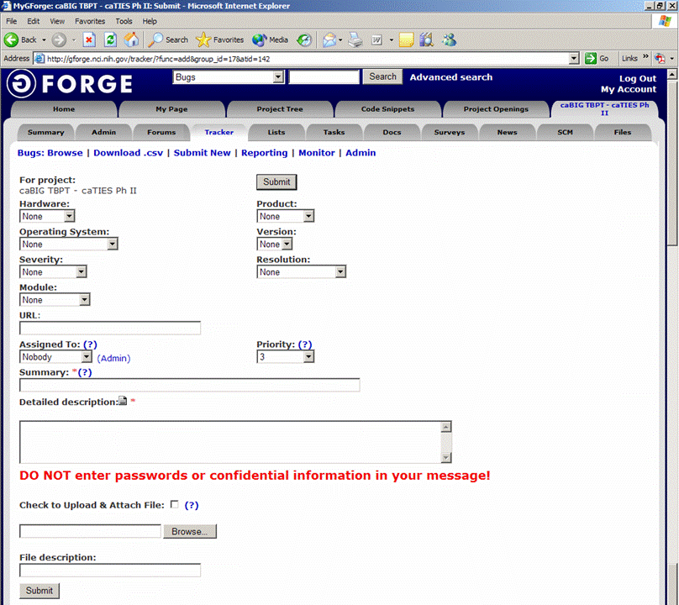
Field Comments
Hardware - List the testing environment hardware. e.g. PC, MAC
Product - Add default to workspace name e.g. caTIES
Operating System - Win 98, Win 2k, Win XP, MAC, etc.
Version - Application version
Severity - If it is an enhancement or a bug with minor to major severity that may not interfere with further testing or completely block any future testing efforts.
Resolution - Only DEVELOPER will update based on the defect
Module - For an application with multiple modules, select appropriate module for the defect reported.
URL - Add URL if any
Assigned to - To be updated by Developer, for whom the ticket is assigned to
Priority - Set a priority based on severity
Summary - Summary of the defect, bug or issue
Detailed Desc. - Details of the defect, bug or issue
Upload file - Attach evidence file
Submit - Submit the bug ticket

Reports
The Test Lead will be responsible for writing and disseminating the following reports to appropriate project personnel as required.

Testing status reports
A weekly or bi-weekly status report will be provided by the Test Lead to project personnel. This report will summarize weekly testing activities, issues, risks, bug counts, test case coverage, and other relevant metrics.

Test Final Report - Sign-Off
A Final Test Report will be issued by the Test Lead. It will certify as to the extent to which testing has actually completed (test case coverage report suggested), and an assessment of the product’s readiness for Release to Production.

Responsibility Matrix
These are the responsibilities of the resources assigned to CTODS Lab Viewer.

Role | Name | Responsibility
PI | Michael Holck | Review and approve test materials
Developers | Anupama Sharma | Unit test
Project Manager | Jennifer Brush | Review and approve test materials
Technical Lead | Lisa Kelley | Review and approve test materials
Testers | Paula Brown | Write and execute test plans, test cases and other test deliverables

Resource & Environment Needs

Testing Tools

Tracking Tools
GForge bug tracker is used by caBIG to enter and track all bugs and project issues. The Test Lead is responsible for maintaining the GForge database.

Test Environment

Hardware
The following is the hardware requirement for testing CCHC
- 2G Hard Disk Space
- 2G Ram
- Linux-compatible CPU

Hardware Infrastructure:
Tier: Server Database
=============================
Dev cbvapp-d1017
QA cbiovqa5010 cbiodb580
Training cbvapp-t1011

Software
In addition to the application and any other customer specified software, the following list of software should be considered a minimum:

Software/Version:
==========================
Apache 2.2.4 Port 80
Tomcat 5.0.28-nonsecure
Jboss 4.0.5(App server)
Postgres (database)
Globus 4.0.2 (embedded in tomcat)
ServiceMix 3.1.2(container)
Maven 2.0.7
Linux (OS)

Bug Severity and Priority Definition
Bug Severity and Priority fields are both very important for categorizing bugs and prioritizing if and when the bugs will be fixed. The bug Severity and Priority levels will be defined as outlined in the following tables below. Testing will assign a severity level to all bugs. The Test Lead will be responsible to see that a correct severity level is assigned to each bug.

The Test Lead, Development Lead and Program Manager will participate in bug review meetings to assign the priority of all currently active bugs. This meeting will be known as “Bug Triage Meetings”. The Test Lead is responsible for setting up these meetings on a routine basis to address the current set of new and existing but unresolved bugs.

Severity List
The tester entering a bug into GForge is also responsible for entering the bug Severity.

Severity ID | Severity Level | Severity Description
1 | Critical | The module/product crashes or the bug causes non-recoverable conditions. System crashes, GP Faults, or database or file corruption, or potential data loss, program hangs requiring reboot are all examples of a Severity. 1 bug.
2 | High | Major system component unusable due to failure or incorrect functionality. Severity. 2 bugs cause serious problems such as a lack of functionality, or insufficient or unclear error messages that can have a major impact to the user, prevents other areas of the app from being tested, etc. Severity. 2 bugs can have a work around, but the work around is inconvenient or difficult.
3 | Medium | Incorrect functionality of component or process. There is a simple work around for the bug if it is Severity. 3.
4 | Minor | Documentation errors or signed off severity 3 bugs.

Priority List
Priority ID | Priority Level | Priority Description
5 | Must Fix | This bug must be fixed immediately; the product cannot ship with this bug.
4 | Should Fix | These are important problems that should be fixed as soon as possible. It would be an embarrassment to the company if this bug shipped.
3 | Fix When Have Time | The problem should be fixed within the time available. If the bug does not delay shipping date, then fix it.
2 | Low Priority | It is not important (at this time) that these bugs be addressed. Fix these bugs after all other bugs have been fixed.
1 | Trivial | Enhancements/ Good to have features incorporated- just are out of the current scope.

Bug Reporting
Testing team recognizes that the bug reporting process is a critical communication tool within the testing process. Without effective communication of bug information and other issues, the development and release process will be negatively impacted.

The Test Lead will be responsible for managing the bug reporting process. Testing’s standard bug reporting tools and processes will be used. GForge is the company-wide standard Bug Logging / Tracking tool. Testing and development will enter their data into the GForge database following the field entry definitions defined below.

Terms/Acronyms

TERM/ACRONYM | DEFINITION
API | Application Program Interface
BAH | Booz Allen Hamilton
BCP | Business Continuity Plan
CAT | Client Acceptance Testing
End-to End Testing | Tests user scenarios and various path conditions by verifying that the system runs and performs tasks accurately with the same set of data from beginning to end, as intended.
ER;ES | Electronic Records; Electronic Signatures
N/A | Not Applicable
NCI | National Cancer Institute
QA | Quality Assurance
RTM | Requirements Traceability Matrix
SME | Subject Matter Expert
SOP | Standard Operating Procedure
TBPT | Tissue Bank and Pathology Tools
TBD | To Be Determined
TSR | Test Summary Report
CTODS | Clinical Trials Object Data System

